

Sign In

[Maps](https://www.quora.com/topic/Maps)

[Politics of India](https://www.quora.com/topic/Politics-of-India-1)

[History](https://www.quora.com/topic/History)

[India](https://www.quora.com/topic/India)

**How did the map of India change from 1 AD to the 21st century?**

5 Answers

[Balaji Viswanathan](https://www.quora.com/profile/Balaji-Viswanathan-2)

[**Balaji Viswanathan**](https://www.quora.com/profile/Balaji-Viswanathan-2), History buff.

76k Views • Upvoted by [Biswa Jyoti](https://www.quora.com/profile/Biswa-Jyoti-2), Citizen of the Republic of India

[Balaji](https://www.quora.com/profile/Balaji-Viswanathan-2) is a Most Viewed Writer in [History](https://www.quora.com/topic/History).

***Warning: This will be a Map de Force with a couple of dozen maps. Brace yourself.***  
  
  
**3000 - 1000 BCE**  
Let's start from the Indus valley civilization. This was among the 4 oldest civilizations. It was a pioneer in city building, sanitation, pottery and trade.

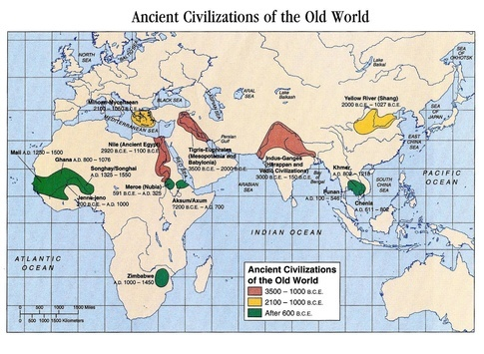

As a 200-year drought hit the Indus Valley, the civilization started moving much more east and south. There is a period of Indian history from 1500 BCE - 500 BCE, where we clearly don't know what happened.  
  
**600 BCE - The Age of Empires**  
This is the era of the Mahajanapadas and Mahabharata is believed to have happened in this period. The 11 in the map below is the Kuru kingdom (of Kauravas).

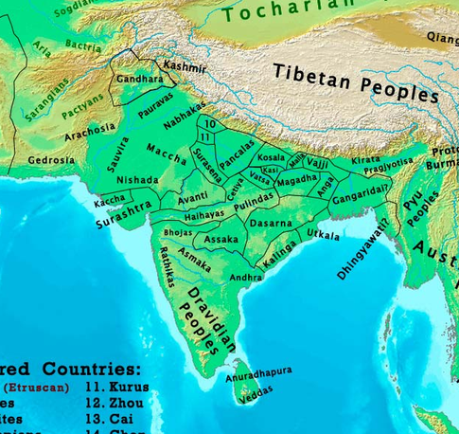

**323 BCE - Invasion of Alexander**  
After various wars (some of them immortalized in Indian epics), the Magadhas started consolidating really big under the Nanda Empire. This is how India looked after Alexander attacked India. The Magadhas however didn't get a chance to fight the great conquerer.

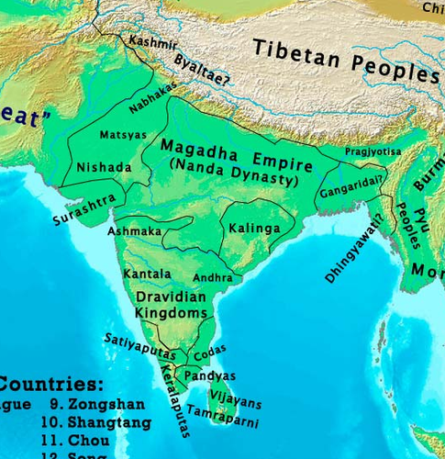

**200 BCE Rise of the Mauryas**  
The attack of Alexander left some Indians, like the Taxila professor Chanakya, really angry and a massive empire followed the Nandas. It was build by Chandragupta and watered by Ashoka. For the first time, all of India came under 1 rule. Even the south Indian kings for the first time became vassals to Ashoka.

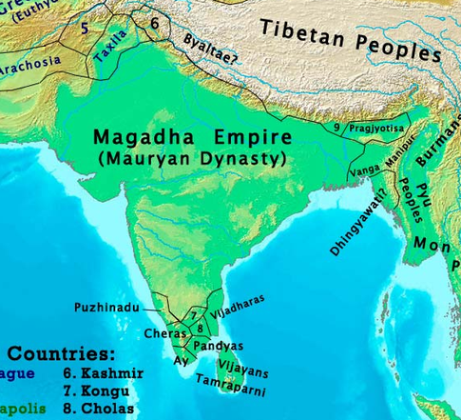

**100 BCE - the rule of Indo-Greeks**  
Good things end eventually and after a century, the Mauryans were done. This time a whole bunch of Indo-Greeks (from various intermarriages) started taking over. Period of confusion like the period before 300 BC.

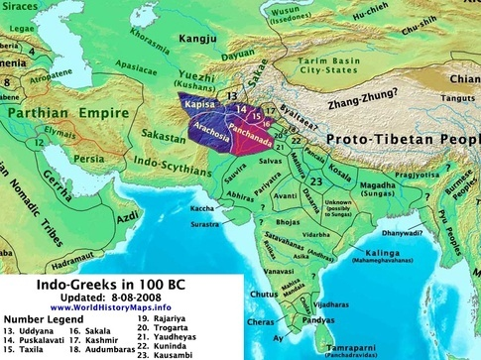

**1 CE - Consolidation begins**  
Around this time, things again started to consolidate. The Indo-Parthians, Indo-Scythians (cross between Indians and Central Asians), Satvahanas of Andhra and Kalingas of Orissa ruled vast territories. You can already see Manipur in North East appearing now.

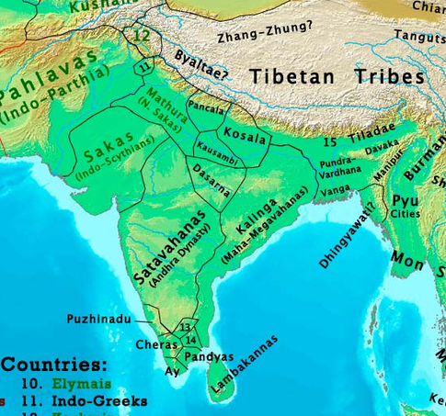

**100 CE - The Kushans Take over**  
This is the period when the Central Asians had a lot of influence. Emperor Kanishka was the best of the lot and many central Asian nations became a part of India. The capitals were Peshawar, Taxila, Mathura and Bagram (Afghanistan). Satvahanas still rule the south and they were responsible some of the equisite art of central India - Amaravati and Sanchi.

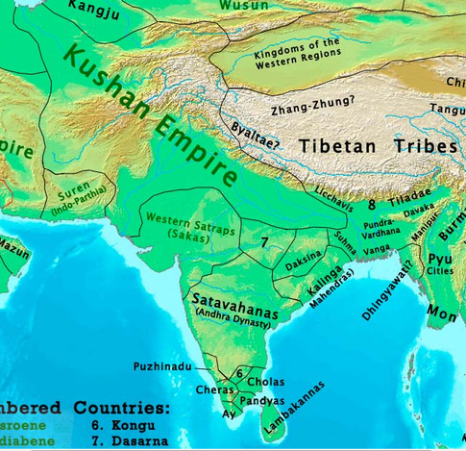

**480 CE- Guptas at the peak**  
After the Kushanas came the Guptas - the golden age of India. They took India to its heights in culture, economy and science. You can also see that the south has its first change in a long time (Cholas, Cheras and Pandyas replaced by the Kalabharas) and the Kamarupa kingdom of Assam gaining momentum. Kalingas would also be reduced greatly

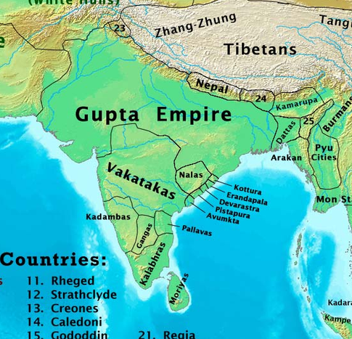

**500 CE- Tragedy strikes India**  
After 2 centuries of rule, the Guptas are finally pushed back by the Hunas of Central Asia. Central Asian nomads also destroyed the Sassanids and Romans in the same period. Like the Mauryas and Nandas, they ruled from Patna.

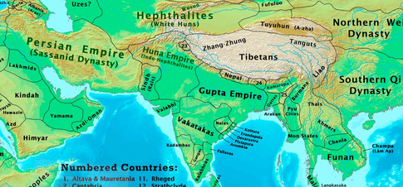

**600 CE Harsha's empire**  
After the fall of the Guptas, Emperor Harsha would take the fight to the Hunas and drive away the invaders. He would try to bring some of the golden age of Guptas back, but his empire would break as soon as he died. You can also see that the Kalabharas have finally been taken over by the Chola, Chera, Pandyas of the south. After this, Kalabharas would be completely wiped from Tamil conscience. The Pallavas would start to flex their muscles and build some of the great rock-cut temples, such as Mahabalipuram.

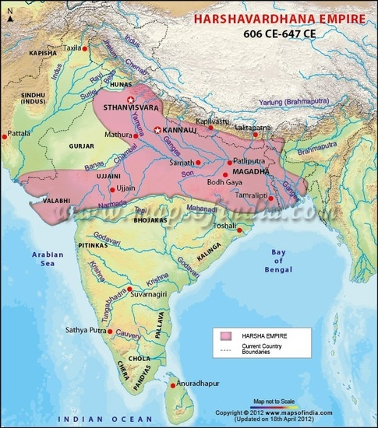

**800 CE Rise of the Palas**  
This was a Buddhist kingdom from the east of India. The Palas took the Gupta build Nalanda university to its heights.

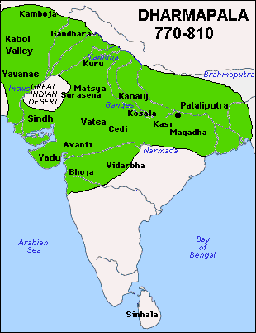

**900 CE - Kannauj Dynasty reigns**  
The Gurjars from Kannuj (Uttar Pradesh) would run over the Gupta territory in the north. In the south, the Rashtrakutas and Cholas would fight for supremacy.

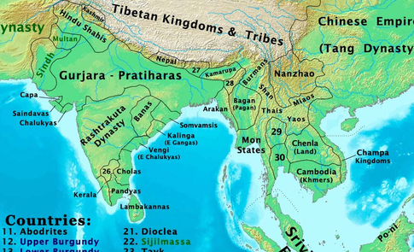

**1000 CE - The rise of Cholas**  
The Rashtrakutas would give way to the Chalukyas in the south and the north would be divided. It is in this period that the Cholas of south would begin their domination, especially over South East Asia. They would control Sri Lanka and a lot of SE Asia.

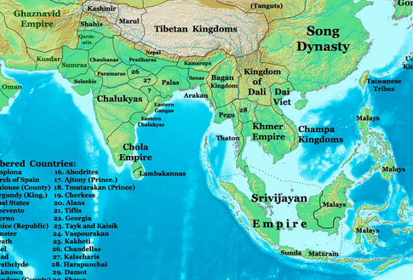

Can you see the looming Ghaznavid empire at the top left? They will slowly start moving into India.  
  
**1200 CE- India under siege**  
This was among the worst periods for India, as the Ghurid Sultanate ate into northern India. Famous universities like Nalanda were destroyed. The south would also implode due to various reasons.

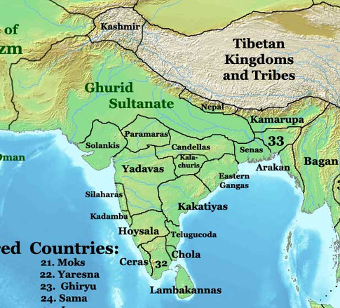

**1400 CE Delhi Sultanates & Vijayanagara**  
North and South would be quite divided in this age. The Afghans of the north would consolidate under the Delhi Sultanate, while south would be consolidated under the Vijayanagar Empire. Some great works of art emerged on both sides.

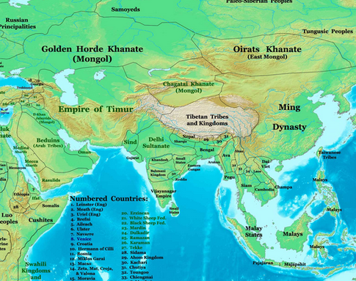

**Mughals (1605- 1707)**  
The Delhi Sultanates gave way to the Mughals who ruled for about 150 years. Some of the great architecture of the north, such as the Taj Mahal was built around this period. After losing its native kingdoms, south continues to be in a state of restlessness.

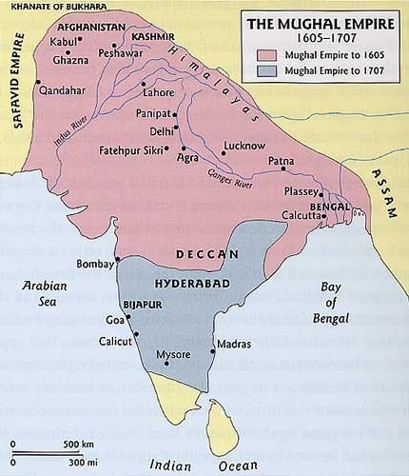

**1750 CE Marathas**  
The Marathas under Sivaji and later kings would start to eat away Mughal empire and had a good chance to consolidate India. However, they would fight with the Ahmad Shah Abdali of Afghanistan and lose in the 3rd battle of Panipat. Their fall would make it easy for the East India Company.

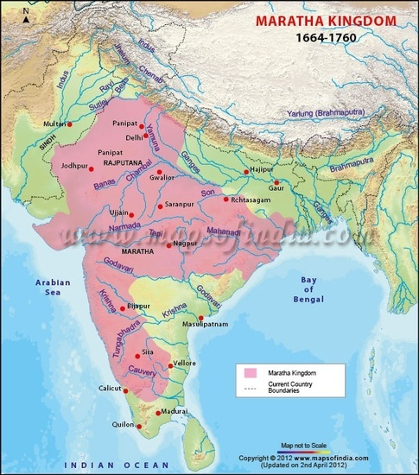

**India map 1857**  
East India Company starts chewing in the pieces left by the Marathas and built an empire. In 1857 this empire was taken over by the British Crown.

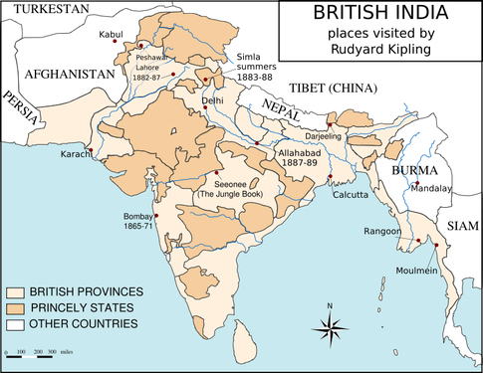

**1930 - British Raj**  
Until 1937, Britain uses its Indian Raj to control their possessions in Asia. Burma was then cut off from India. Ceylon was never under Indian control though as Britain didn't find it as profitable. However, they moved people from India into Ceylon and Malaysia.

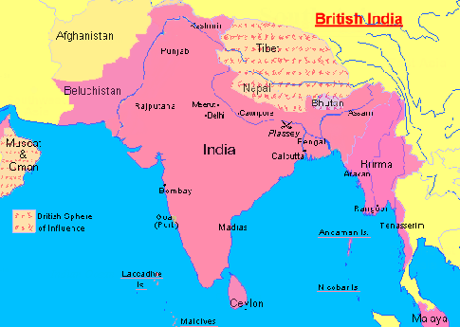

**1947 - The Dawn of Freedom**  
Here is what India looked just before the partition on August 15, 1947.

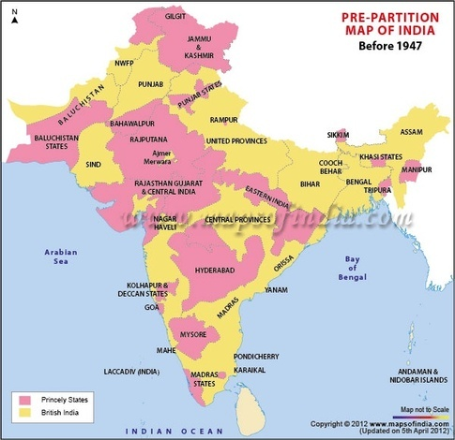

**India in 1953 - State Reorganization**  
In 1953, India started reorganizing states on linguistic lines.

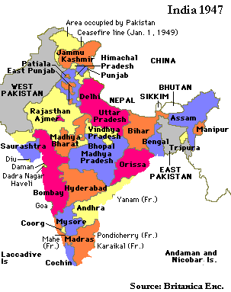

**Present**  
This is our India of the present. It stands like a person with wide open arms.

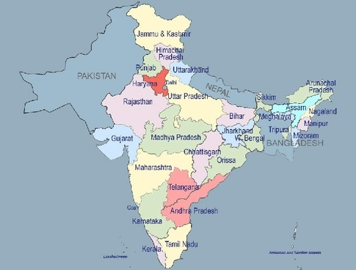

**Summary:**  
Like all nations of the world, India's boundaries wax and waned through the last 5000 years of history. Here is the graph of various Indian empires and what % of the subcontinent they ruled back then. For instance, Mauryas ruled 80%+ of the subcontinent and were between 300-200 BCE. Mughals ruled almost 90%. This first gives you an idea of different empires and their maximum extents.

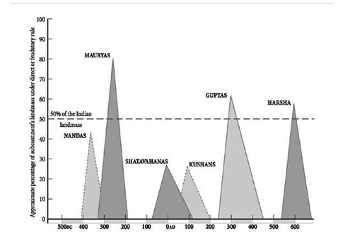

500 BC - 700 CE

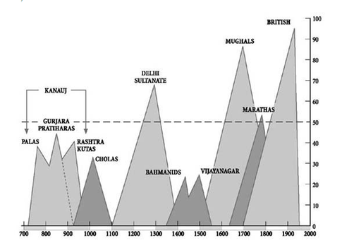

700 CE- 1947  
  
Here is another view of this thanks to [Shaswata Panja](https://www.quora.com/profile/Shaswata-Panja).

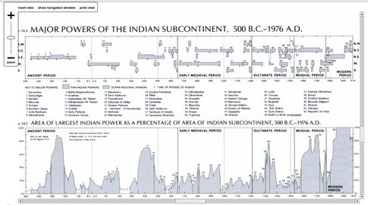

Maps are a courtesy of: [World History Maps by Thomas Lessman](http://www.worldhistorymaps.info/maps.html)

[Updated 18 Dec 2014](https://www.quora.com/How-did-the-map-of-India-change-from-1-AD-to-the-21st-century/answer/Balaji-Viswanathan-2) • [View Upvotes](https://www.quora.com/api/mobile_expanded_voter_list?type=answer&key=a9ysxvshLwi) • Answer requested by [Sushrut Bhat](https://www.quora.com/profile/Sushrut-Bhat)

**Related Questions**

[More Answers Below](https://www.quora.com/How-did-the-map-of-India-change-from-1-AD-to-the-21st-century#MoreAnswers)

* [What is actual indian culture is, for which india is famous? How indian culture can help india in 21st century?](https://www.quora.com/unanswered/What-is-actual-indian-culture-is-for-which-india-is-famous-How-indian-culture-can-help-india-in-21st-century)
* [Can India really surpass the USA by the end of the 21st century?](https://www.quora.com/Can-India-really-surpass-the-USA-by-the-end-of-the-21st-century)
* [How is India known in today's world? What has changed in the 21st century?](https://www.quora.com/unanswered/How-is-India-known-in-todays-world-What-has-changed-in-the-21st-century)
* [India: Will India get extinct from the world map as a result of climate change in the coming 12 years?](https://www.quora.com/India-Will-India-get-extinct-from-the-world-map-as-a-result-of-climate-change-in-the-coming-12-years)
* [What are the world-changing,groundbreaking events of the 21st century?](https://www.quora.com/What-are-the-world-changing-groundbreaking-events-of-the-21st-century)

[Puneeth Babu](https://www.quora.com/profile/Puneeth-Babu)

[**Puneeth Babu**](https://www.quora.com/profile/Puneeth-Babu), India in my heart

2k Views

Firstly, there was no India in 1 AD. It was known as Bharata varsha. It extended from Hindukush mountains in the west to the Arakan yoma and Pegu Yoma mountains in the east and from Himalayas in the North to Indian ocean in the south. This is a tentative map.



And this is the new country of India formed after 1947.

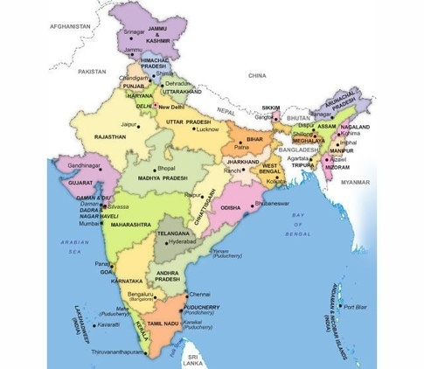

[Written 24 Apr 2015](https://www.quora.com/How-did-the-map-of-India-change-from-1-AD-to-the-21st-century/answer/Puneeth-Babu) • [View Upvotes](https://www.quora.com/api/mobile_expanded_voter_list?type=answer&key=mJYKxnu8vz4)

[Srivastava Kuchibhotla](https://www.quora.com/profile/Srivastava-Kuchibhotla)

[**Srivastava Kuchibhotla**](https://www.quora.com/profile/Srivastava-Kuchibhotla)

3.1k Views

There was no India to begin with in 0 A.D or for the matter of fact India as we know existed after the colonialisation, where a unique identity of a nation emerged as a response to British.  
  
If you are referring to the empires and provinces of the Emperors (who you claim/call to be Indian) then the largest extent of the Indian empire is borders of Afghanistan ruled by the Mauryas and the Guptas and the sourthen/south eastern extent of India is Indonesia/Phillipines ruled by Cholas. Of course these rulers are from different times.  
  
But to be specific the idea of a India as a nation state did not emerge until colonialisation or for the matter of fact the idea of nation state in Europe emerged after Napoleonic  Wars.So the nation state itself is a new concept  and as such the boundaries as thus are undefined.

[Written 25 Jul 2014](https://www.quora.com/How-did-the-map-of-India-change-from-1-AD-to-the-21st-century/answer/Srivastava-Kuchibhotla) • [View Upvotes](https://www.quora.com/api/mobile_expanded_voter_list?type=answer&key=8OxP0WWhOSF)

[Maheswara Sastry M](https://www.quora.com/profile/Maheswara-Sastry-M)

[**Maheswara Sastry M**](https://www.quora.com/profile/Maheswara-Sastry-M), A fan of History with a skeptic mind

1.9k Views

An excellent narration with illustrative maps. Mr Balaji, you inspire all of us that one can be an expert in any domain and not necessarily in the field of your job. Kudos!!!

[Written 3 Jun 2015](https://www.quora.com/How-did-the-map-of-India-change-from-1-AD-to-the-21st-century/answer/Maheswara-Sastry-M) • [View Upvotes](https://www.quora.com/api/mobile_expanded_voter_list?type=answer&key=odxKeA65Q1D)

[Girish Chandrashekar](https://www.quora.com/profile/Girish-Chandrashekar)

[**Girish Chandrashekar**](https://www.quora.com/profile/Girish-Chandrashekar), I know about history

2.3k Views

During 600 CE Harsha's empire, in below map badami chalukya kings were dominating southern india. Pullikeshi II drove Harsha vardahana and conferred with dakshina patheshwara.

[Written 26 Apr 2015](https://www.quora.com/How-did-the-map-of-India-change-from-1-AD-to-the-21st-century/answer/Girish-Chandrashekar) • [View Upvotes](https://www.quora.com/api/mobile_expanded_voter_list?type=answer&key=a1KRBvvaXMQ)

**Related Questions**

* [How much powerful India is in 21st century?](https://www.quora.com/unanswered/How-much-powerful-India-is-in-21st-century)
* [What are India's contributions to the world in 21st century so far?](https://www.quora.com/What-are-Indias-contributions-to-the-world-in-21st-century-so-far)
* [Is the 21st century India's century?](https://www.quora.com/Is-the-21st-century-Indias-century)
* [How has Indian pride changed in the 21st century?](https://www.quora.com/How-has-Indian-pride-changed-in-the-21st-century)
* [Epics of India: If Mahabharata happened in 21st century what it would be like?](https://www.quora.com/Epics-of-India-If-Mahabharata-happened-in-21st-century-what-it-would-be-like)
* [India: Will 150 million Indians die due to the great Himalayan earthquake as predicted by the USGS in the 21st century?](https://www.quora.com/India-Will-150-million-Indians-die-due-to-the-great-Himalayan-earthquake-as-predicted-by-the-USGS-in-the-21st-century)
* [If India was the richest civilisation in the world from 1 AD to 1700 AD, why can't India portray itself as the richest civilisation?](https://www.quora.com/If-India-was-the-richest-civilisation-in-the-world-from-1-AD-to-1700-AD-why-cant-India-portray-itself-as-the-richest-civilisation)
* [India: Isn't it strange in 21st century that people are going for arranged marriages instead of love marriages in India?](https://www.quora.com/India-Isnt-it-strange-in-21st-century-that-people-are-going-for-arranged-marriages-instead-of-love-marriages-in-India)

[Will India ever become a superpower?](https://www.quora.com/Will-India-ever-become-a-superpower-1" \t "_blank)

[What are the canonical texts on world history (from 1st to 21st Century)?](https://www.quora.com/What-are-the-canonical-texts-on-world-history-from-1st-to-21st-Century" \t "_blank)

* [How has basketball changed from the 20th to the 21st century?](https://www.quora.com/How-has-basketball-changed-from-the-20th-to-the-21st-century)
* [How is school changing in the 21st century in India?](https://www.quora.com/How-is-school-changing-in-the-21st-century-in-India)
* [How has science journalism changed in the 21st century?](https://www.quora.com/unanswered/How-has-science-journalism-changed-in-the-21st-century)
* [Why do Madrasas exist in 21st century secular India?](https://www.quora.com/Why-do-Madrasas-exist-in-21st-century-secular-India)
* [How relevant is Nationalism in 21st century India?](https://www.quora.com/How-relevant-is-Nationalism-in-21st-century-India)

Related Questions

* [What is actual indian culture is, for which india is famous? How indian culture can help india in 21st century?](https://www.quora.com/unanswered/What-is-actual-indian-culture-is-for-which-india-is-famous-How-indian-culture-can-help-india-in-21st-century)
* [Can India really surpass the USA by the end of the 21st century?](https://www.quora.com/Can-India-really-surpass-the-USA-by-the-end-of-the-21st-century)
* [How is India known in today's world? What has changed in the 21st century?](https://www.quora.com/unanswered/How-is-India-known-in-todays-world-What-has-changed-in-the-21st-century)
* [India: Will India get extinct from the world map as a result of climate change in the coming 12 years?](https://www.quora.com/India-Will-India-get-extinct-from-the-world-map-as-a-result-of-climate-change-in-the-coming-12-years)
* [What are the world-changing,groundbreaking events of the 21st century?](https://www.quora.com/What-are-the-world-changing-groundbreaking-events-of-the-21st-century)
* [How much powerful India is in 21st century?](https://www.quora.com/unanswered/How-much-powerful-India-is-in-21st-century)
* [What are India's contributions to the world in 21st century so far?](https://www.quora.com/What-are-Indias-contributions-to-the-world-in-21st-century-so-far)
* [Is the 21st century India's century?](https://www.quora.com/Is-the-21st-century-Indias-century)
* [How has Indian pride changed in the 21st century?](https://www.quora.com/How-has-Indian-pride-changed-in-the-21st-century)
* [Epics of India: If Mahabharata happened in 21st century what it would be like?](https://www.quora.com/Epics-of-India-If-Mahabharata-happened-in-21st-century-what-it-would-be-like)

[Top Stories](https://www.quora.com/)

**[Read More](https://www.quora.com/What-is-considered-good-conservatism-to-a-progressive-liberal" \t "_blank)**

[**What is considered good conservatism to a progressive / liberal?**](https://www.quora.com/What-is-considered-good-conservatism-to-a-progressive-liberal)

[Ernest W. Adams](https://www.quora.com/profile/Ernest-W-Adams)

[Ernest W. Adams](https://www.quora.com/profile/Ernest-W-Adams), Game Design Consultant, Author, and Professor

7.5k Views • [Ernest](https://www.quora.com/profile/Ernest-W-Adams) is a Most Viewed Writer in [Politics](https://www.quora.com/topic/Politics) with [640+ answers](https://www.quora.com/profile/Ernest-W-Adams/answers/Politics).

Good conservatism consists of retaining the things about the past that were and are good. For example, I'm conservative about not allowing advertising in schools -- there was none when I was a child and I believe there should be none now. "Conservative" education boards have turned to advertising because they don't want to levy the taxes necessary to educate children properly. As far as I'm con...

**[Read More](https://www.quora.com/How-is-Bernie-Sanders-considered-a-socialist-when-in-any-other-countries-he-would-be-considered-a-moderate-capitalist" \t "_blank)**

[**How is Bernie Sanders considered a socialist when in any other countries he would be considered a moderate capitalist?**](https://www.quora.com/How-is-Bernie-Sanders-considered-a-socialist-when-in-any-other-countries-he-would-be-considered-a-moderate-capitalist)

[Andrew Weill](https://www.quora.com/profile/Andrew-Weill)

[Andrew Weill](https://www.quora.com/profile/Andrew-Weill), Student of politics and occasional activist

8k Views • [Andrew](https://www.quora.com/profile/Andrew-Weill) is a Most Viewed Writer in [Politics of the United States of America](https://www.quora.com/topic/Politics-of-the-United-States-of-America-1).

To a certain extent, because the labeling of him as a "socialist" is convenient for both supporters and opponents.

It is my general observation that neither the media, nor the American public, have much taste for careful, nuanced, accurate explanations.  If there's a one-word label to slap on, this eliminates the need for actual critical thinking and evaluation.

To be explicit, this is a proble...

**[Read More](https://www.quora.com/What-is-best-for-an-American-politician-Being-a-senator-or-a-governor" \t "_blank)**

[**What is best for an American politician: Being a senator or a governor?**](https://www.quora.com/What-is-best-for-an-American-politician-Being-a-senator-or-a-governor)

[Dan Holliday](https://www.quora.com/profile/Dan-Holliday)

[Dan Holliday](https://www.quora.com/profile/Dan-Holliday), I am an American

8.3k Views • Upvoted by [Kyle Murao](https://www.quora.com/profile/Kyle-Murao),American

[Dan](https://www.quora.com/profile/Dan-Holliday) is a Most Viewed Writer in [The United States of America](https://www.quora.com/topic/The-United-States-of-America).

Both are stepping stones to the White House.  The senate gives you access to global, military and other federal power brokers/influencers.  Governor gives you executive experience.  On the whole, the governorship is considered slightly better preparation. But state governor plus Congress or Senate plus cabinet secretary are both about he same.

[Sitemap](https://www.quora.com/sitemap)

[#](https://www.quora.com/sitemap/alphabetical_topics/0)

[A](https://www.quora.com/sitemap/alphabetical_topics/a)[B](https://www.quora.com/sitemap/alphabetical_topics/b)[C](https://www.quora.com/sitemap/alphabetical_topics/c)[D](https://www.quora.com/sitemap/alphabetical_topics/d)[E](https://www.quora.com/sitemap/alphabetical_topics/e)[F](https://www.quora.com/sitemap/alphabetical_topics/f)[G](https://www.quora.com/sitemap/alphabetical_topics/g)[H](https://www.quora.com/sitemap/alphabetical_topics/h)[I](https://www.quora.com/sitemap/alphabetical_topics/i)[J](https://www.quora.com/sitemap/alphabetical_topics/j)[K](https://www.quora.com/sitemap/alphabetical_topics/k)[L](https://www.quora.com/sitemap/alphabetical_topics/l)[M](https://www.quora.com/sitemap/alphabetical_topics/m)[N](https://www.quora.com/sitemap/alphabetical_topics/n)[O](https://www.quora.com/sitemap/alphabetical_topics/o)[P](https://www.quora.com/sitemap/alphabetical_topics/p)[Q](https://www.quora.com/sitemap/alphabetical_topics/q)[R](https://www.quora.com/sitemap/alphabetical_topics/r)[S](https://www.quora.com/sitemap/alphabetical_topics/s)[T](https://www.quora.com/sitemap/alphabetical_topics/t)[U](https://www.quora.com/sitemap/alphabetical_topics/u)[V](https://www.quora.com/sitemap/alphabetical_topics/v)[W](https://www.quora.com/sitemap/alphabetical_topics/w)[X](https://www.quora.com/sitemap/alphabetical_topics/x)[Y](https://www.quora.com/sitemap/alphabetical_topics/y)[Z](https://www.quora.com/sitemap/alphabetical_topics/z)

[About](https://www.quora.com/about) - [Careers](https://www.quora.com/careers) - [Privacy](https://www.quora.com/about/privacy) - [Terms](https://www.quora.com/about/tos) - [Contact](https://www.quora.com/contact)